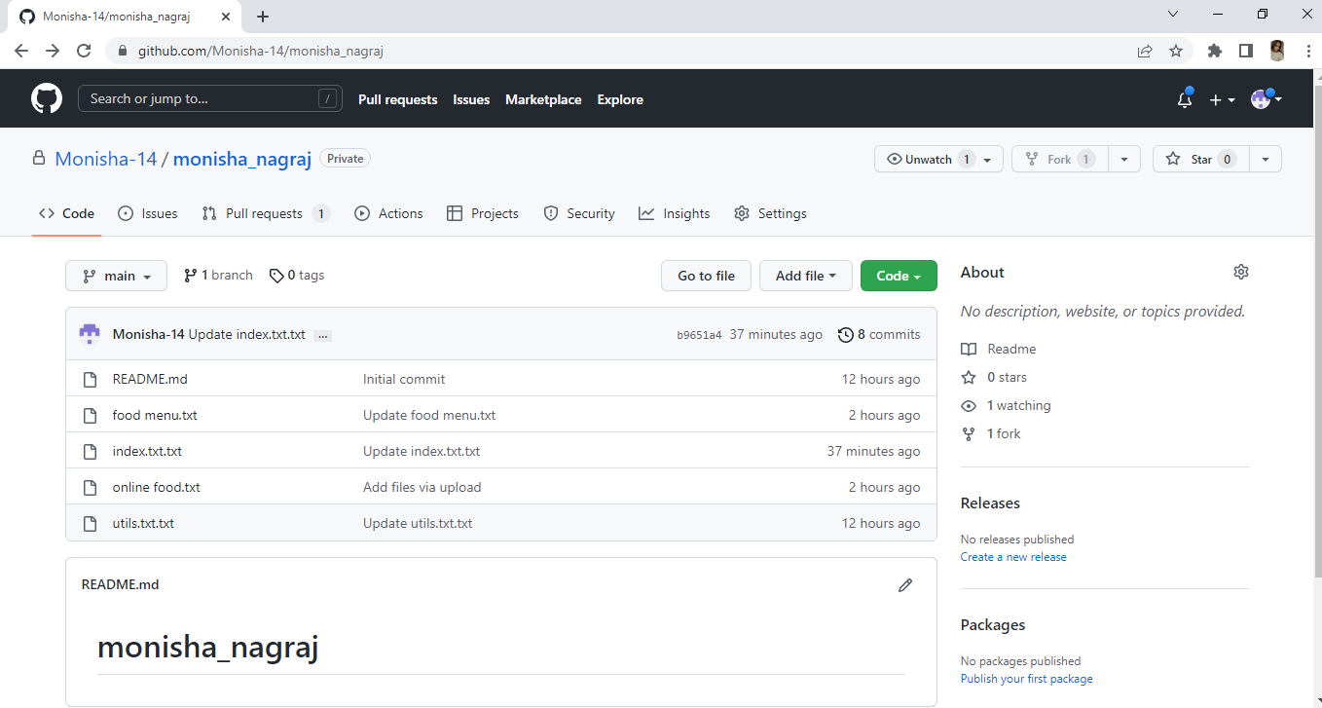

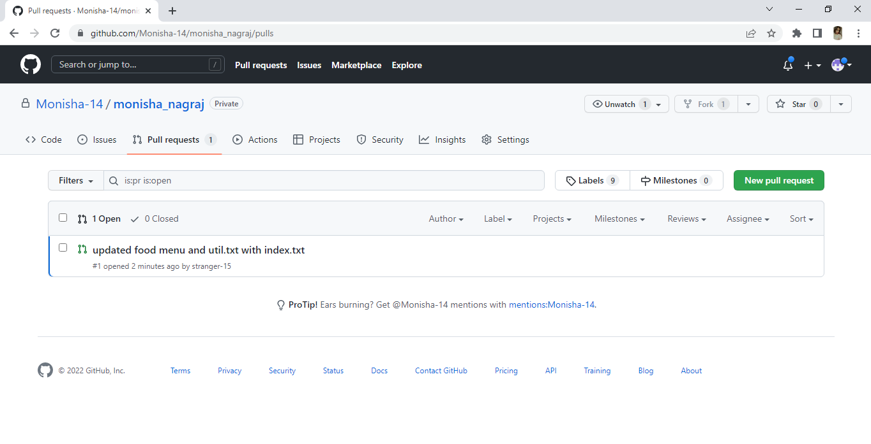

|  |  |
| --- | --- |
| CONFIGURATION ITEM | FILE TYPES |
| client | Txt |
| constants | Txt |
| Pre_requisites | Txt |
| requirements | js |
| scanner | Txt |
| Setting | Txt |
| skill | js |
| url | txt |
| wsgi | Txt with js |
|  |  |



